THE JOINT MINIATURE SCHNAUZER EYE FUND
raising money to support research into the three eye conditions found in our breed
announce a NEW
BRANDED PRODUCT
all proceeds in aid of the JMSEF

Can be pre-ordered and collected at Miniature Schnauzer Club,
Northern Schnauzer Club & Schnauzer Club of Great Britain events or
delivered by post (P&P details below).

T-towel £7.50 each or
3 or more £7.00 each.

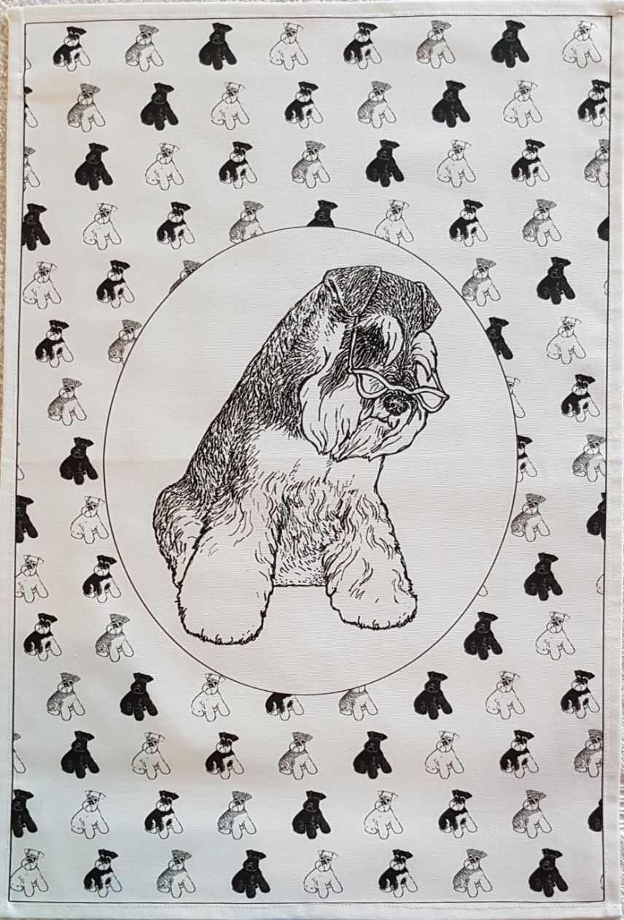

Size (approx) L: 66cm/26”, W:45cm/17.75”

P&P: 1 t-towel 1st class 1.60, 2nd class £1.20
2 t-towels 1st class £2.20, 2nd class £1.80

Cheque or BACs payments accepted, for details contact
Sue 01526 860087 or email isaura12@btinternet .com

